

Report on Project

**Course Title:** Embedded Systems

**Course Code:** CSE423

**Project Name:** Security system with multiple ways of alarm

**Submitted To**

Mosharraf Hossain Khan

**Lecturer Of**

Department of Computer Science & Engineering

Daffodil International University

Group Members

* Md Ahsanul Kabir Bhuiyan ID:171-15-8635
* Kazi Salith Ur Rahman ID: 171-15-8864
* SK Salman Ahmed Sabbir ID: 171-15-9398
* Mariom Akter ID:171-15-9013
* Afzal Hossain sagar ID:171-15-8939
* Naimur Rahman ID:171-15-9570
* Tanjil Islam shuvo ID:171-15-9043

**Submission Date:** 17.08.2020

**Introduction:**

* Multiple security alarm system is basically used for security purpose. Likes, office, court, shopping mall, etc. security
* This project mainly focuses of detecting any infeperate from the human Fool that means. It will find any presents of human in specific range.
* But it can also detecting animal which give infeperate from the animal Fool and any Object.
* Our Project has 3 types of alert system likes,

i) Led Display

ii) Piezo

iii) Light blub

* We can called little bit limitation of Our Project likes, it can perform small amount of Ares.

**Use of components and works**

* Arduino board

### Arduino Uno R3

### Connect the wires with the breadboard and for the sketch connection

### LCD 16 x 2

### We use this monitor or screen for the display alarm purpose. This display shows the object is how far from the system and also the alert message.

### Potentiometer - 250 kΩ

### Resistor - 220 Ω

### PIR Sensor

### This sensor is used for the movement of the object. For not performing two sensors at a time in the tinkercad, we cannot show the works of it but we show the work of it on “Serial Monitor”.

### Ultrasonic Distance Sensor

### This sensor we use for the measuring distance of an object to detect. It acknowledges us that an object is how far or near from the system and sounds also vary with the low and high distance of the object for our easy clarification.

### Light bulb

### This is the another alert option in this system. Te bulb is blinking continuously when there is an object in the specified area.

### Piezo

### This is a buzzer we use for creating sound or noise as an alarm.

### ****Circuit Diagram****

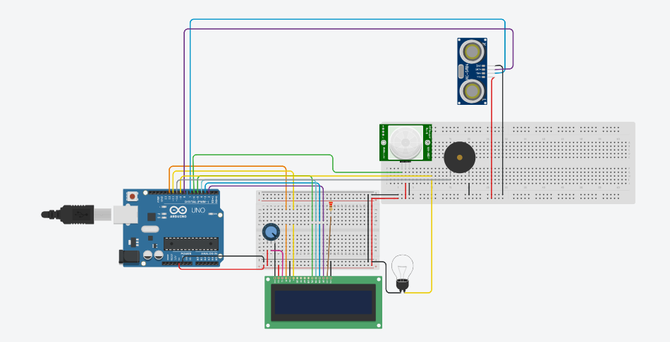

**Sketch:**

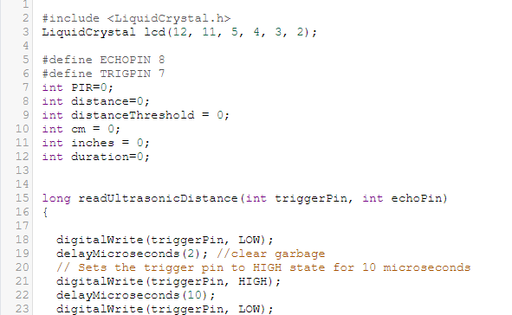

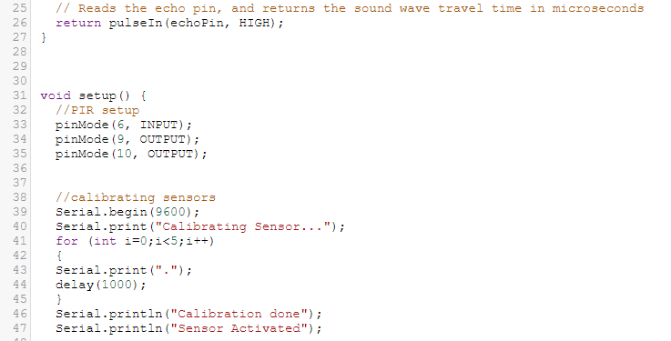

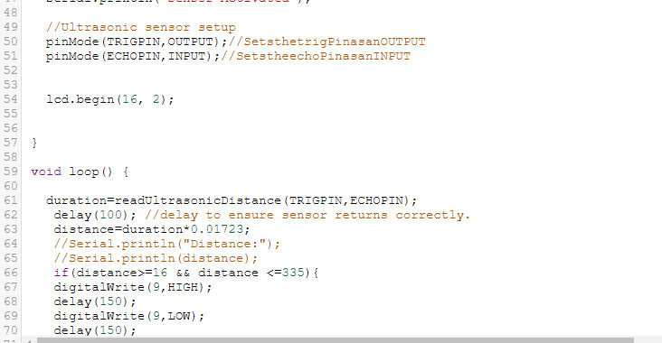

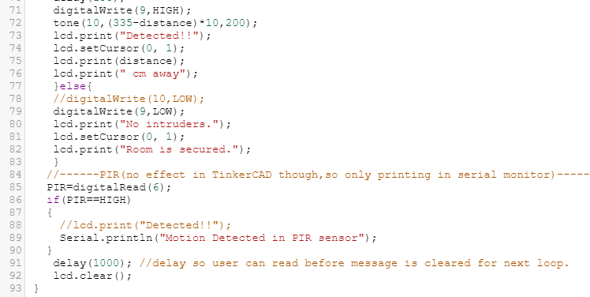

**Working Stairs:**

* Our main working process done by Ultrasonic Distance Sensors when this sensors find any infeperate from the human Fool in sensor’s range.
* Then it give Beep sound. This Beep sound give soft sound when the object is Afar and it give Forte when object is near.
* And light will blink
* It gives a Alert is “Detected” and show range of Detected Object.
* Our project range is Minimum 15cm and Maximum 335cm.

**Advantages of security system with multiple ways of alarm**

Most important advantage of this system that is

1) To detect any kind of object

2) Amy kind of security like home security, shopping mall, restaurant or institutional security etc.

3) Use this system in mobile to protect our valuable accessaries or things

4) Deters crime.

**Necessity of security system with multiple ways of alarm:**

Our main target is to secure or protect our necessary things. For securing our valuable things, 3 types of alarm sysrems are used in this project that is

1) LCD

2) Bulb Link

3) Distance from a person

That's why this project is very necessary in our day to day life.

**Limitations:**

* **We can called little bit limitation of our project likes, it can perform small amount of ares.**

* Calculations of very high frequency signals is not possible using arduino as the sampling rate of adc is low.

* The input signal must be non ac and must posses a magnitude of less than 5v.

* Heavy mathematical functions like inverse trigonometry, modulus

**• Operation, complex equations cannot be performed by the arduino software.**

**• The main module or the handset is not in the cellular ranges we can't control the devices.**

**• The sensors use rf transmitter and receiver which has limited range, hence sensors have to be in close vicinity of the main module**

**— limited arduino (nano) memory,**

**— limited arduino communication via uart,**

**— Limited arduino mall buffer.**

**Future plan:**

# Multiple security alarm system we can connect to the phone and take it anywhere. In this we can keep ourselves safe. Let us know before any difficulty arises. Besides, we can use this system in many places like office, court, shopping mall.

# Here are a few reasons how that is true. Protects valuables. ...

# Deters crime.

# Allows remote access to your home.

# Lowers homeowner's insurance. .

# Notifies you of fire or gas problems. .

# Helps keep tabs on kids.

# Improves electricity management.

# Makes room for peace of mind.

# Home and commercial properties that have security systems installed are known to have a lower risk of being targeted by criminals. Knowing that they have a higher chance of getting caught, the alarm system will persuade potential thieves that your property is not worth the hassle.

**Conclusion:**

This project is about security.

Mainly we tried to implementing a project which can protect any object(which can be anything).

So there are 3 alarm system in future our target will be make it very handy and responsive

THE END